This document describes how the list of notifications are sent to the patient based on the doctor prescription.

**Doctor Prescription List**

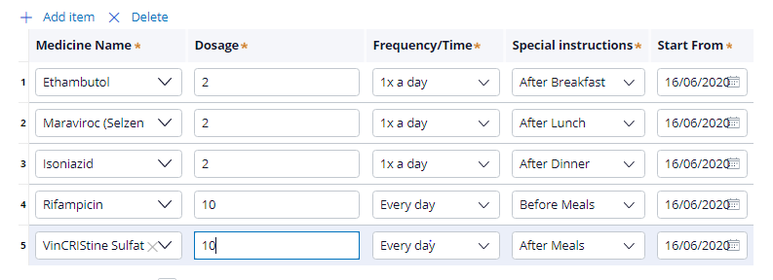

**Records inserted for the Ethambutol medicine for 1 x a day scenario**

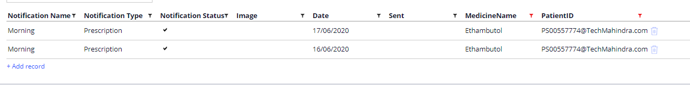

**Records inserted for the Isoniazid medicine for 1 x a day scenario**

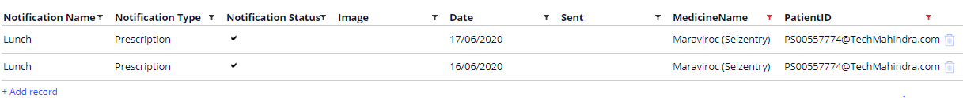

**Records inserted for the Maraviroc medicine for 1 x a day scenario**

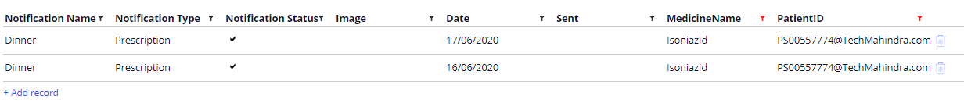

**Records inserted for the Rifampicin medicine for Everyday scenario**

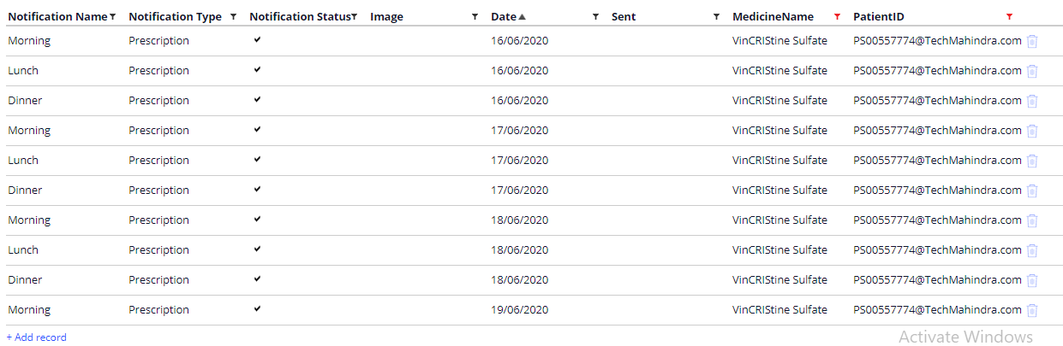

**Records inserted for the VinCRIStine Sulfat medicine for Everyday scenario**

